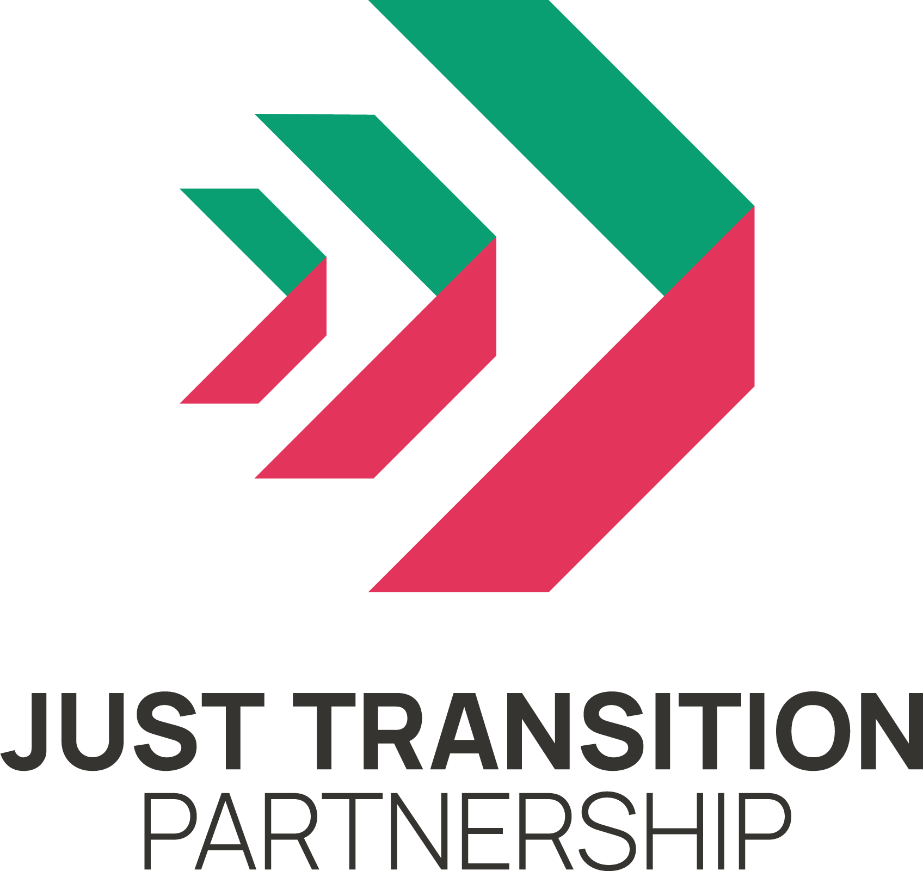
Roundtable on Just Transition Plan for
Land Use and Agriculture
25 July 2023

Summary

In order to input to the Scottish Government’s Just Transition Plan for Land Use and Agriculture, the Partnership organised an online round table on 25 July 2023. It drew in representatives from environmental and climate campaign groups, trade unions, land workers and crofters, academics and organisations advocating for rural Scotland.

This summary has been drawn from contributions made by all participants. It does not necessarily represent the views of the Just Transition Partnership or its members.

CONTEXT

KEY POINTS
Agriculture is a net emitter of greenhouse gases; so pressure is on to reduce emissions from land and agriculture to zero wherever possible.

The current agriculture regime supports unsustainable farming practices and is regarded as unjust by many present.

The need to sequestrate carbon through woodlands and forestry as well as to provide places for generation of renewable electricity means that there is pressure on use of marginal agricultural land and on sporting estates.

The event started with an overview of the sector and its emissions. The participants heard that agriculture is a net emitter; and that taken with land and forestry, this sector emits more greenhouse gases than any other; although it does also sequestrate carbon, mainly in forestry. Greenhouse gases include methane and nitrous gases as well as CO2 and come from degrading of peatlands and soils, fertilisers, muirburn and livestock as well as the burning of fossil fuels.

Given its significant contribution to Scotland’s overall emissions, it was suggested that the plans in the Climate Change Plan Update are not sufficiently ambitious, nor is the vision suggested by the Scottish Government’s discussion paper.. There was concern that these documents don’t give a full picture of the sector, concentrating mainly on agriculture, and that the needs of small producers, migrant workers and women, for example, do not receive attention. A focus on owner-occupiers was seen to strip out the public good element, which should be at the core of the Plan.

Both forestry and agriculture are shaped by government subsidy. The current agriculture regime supports unsustainable farming practices and is regarded as unjust by many present, giving most money to the largest and most polluting landowners. A new system in Scotland is in preparation which could rectify this..

Scotland both imports most of the food it consumes, and exports most of the food which it produces. Supermarket purchasing of domestic produce dominates and drives down prices leading to lower wages and less secure work. It is now also as well adding pressure to reduce greenhouse gas emissions which is often experienced as yet another demand to be met from the tight profit margins of producers. Working conditions are poor - long hours, low pay, precarious and the workforce is dispersed and frequently employed seasonally.

Farms are mostly small enterprises, economically and in terms of numbers of workers, or are self-employed, as are crofters. Many are struggling financially. To respond to the need for rapid change, they will need advice and support. They are currently more attuned to messages about biodiversity than about climate change emissions.

Overall, land ownership is very concentrated and there are few opportunities for new entrants to farming. This is being exacerbated by financialised investment in land to capture carbon offset credits.

The need to sequestrate carbon through woodlands and forestry as well as to provide places for generation of renewable electricity means that there is pressure on use of marginal agricultural land and on sporting estates, where management of land for grouse and deer is unsustainable in terms of both carbon emissions and biodiversity.

VISION

KEY POINTS:
Our vision for land use and agriculture has to enable all of us to benefit - it should be seen as for the public good.

Our land has to be net zero and nature positive - while ensuring economic security for rural communities, improving working conditions and providing more of the food which Scotland consumes.

A properly planned and resourced transition can increase employment on the land; and by creating more certainty and diversity, it should lay the foundations for better pay and more security, which will benefit rural communities

The discussions explored the many uses of land and the many demands which we make on it. The meeting heard about the experiences of those who work onland as well as those who seek to preserve its biodiversity and to cut emissions to zero.

Across this, there was a consensus that our vision for land use and agriculture has to enable all of us to benefit - it should be seen as for the public good, not primarily as a profit generator for large landowners. Responding to the twin challenges of climate change and nature loss, our land has to be net zero and nature positive -while ensuring economic security for rural communities, improving working conditions and providing more of the food which Scotland consumes.

To do this, it was recognised that it has to balance the needs of agriculture, food production, forestry, peatland management and renewable energy. The Scottish Government will have to provide much more clarity and ambition than it has so far. For example:
- if converting peatland from a source of emissions to a sink is a national priority, it will need guide that process.
- if the shift to more woodlands and protection of peatland requires more land, the implications for sporting estates and marginal agriculture should be stated plainly.
- if the sale of land for carbon offsetting opportunities is allowed, the government will have to show how these contribute to the national carbon accounting.

The government has said that the opportunities to capture and sequester carbon by this sector are to be used by the whole economy, to compensate for residual hard-to-abate emissions from other sectors. This means that the pressure is on to reduce emissions from land and agriculture to zero wherever possible – not just to move towards ‘low’ emissions. For many farmers, landowners and landworkers these are new requirements and they will require training, advice, support and incentivisation through the subsidy schemes.

As a part of sustainable agriculture and forestry, in which biodiversity is an objective as well as emission reductions, Circular Economy principles should be introduced with an emphasis on minimisation of waste and regeneration of soils and natural systems.

A properly planned and resourced transition should be able to increase existing levels of employment on the land while changing the content of many aspects of the work done. By creating more certainty and diversity, it should lay the foundations for better pay and more security which will benefit rural communities and agricultural workers immensely, including migrant workers.

This vision includes opportunities to increase community benefit and and to create more diverse and less concentrated patterns of ownership. It certainly requires the end of financial subsidies which support the pattern of large-scale land ownership. New entrants should benefit as should small producers who can be linked to local supply chains in a more sustainable food system.

This is a vision of change rooted in respect for nature and for rural communities through which employment on and appreciation of the land can grow and Scotland’s nature can be restored to health.

WHAT SHOULD BE DONE?

KEY POINTS:
Government has to bring together planning, regulation, funding and delivery roles.

Key tools for driving change will be the agriculture and forestry subsidy regimes.

A strengthened Land Rights and Responsibilities Statement should be mandatory on large estates.

For many farmers, landowners and landworkers these are new requirements and they will require training, advice, support and incentivisation through the subsidy schemes.

Public bodies might work together to create a direct labour workforce which with a diversity of tasks and skills can provide work all year round.

An overall planned approach will ensure that there is sufficient housing available at affordable rents and prices - enabled through planning and land reform.

Participants in the round table favoured a more vigorous process of land. reform leading to more community ownership and the break up of large estates.

Our participants all recognised that Scotland in its current state is a long distance from this vision but they also brought numerous and diverse suggestions of the actions needed. Many felt that it is necessary that the grand scale and scope of change has to be clearly communicated, in particular by Government, since this is not fully recognised by many who are directly involved including large landowners and estate managers.

It was felt that Government has to bring together planning, regulation, funding and delivery roles; and so give strong leadership and direction to all the main actors in the sector. Regional Land Use Partnerships should be given more of a role, alongside local democracy, in guiding implementation of national objectives in the Plan.

The key tools for driving change will be the agriculture and forestry subsidy regimes, which should be reformed to stop subsidising unsustainable practices and introduce a redistributive payment system. There were calls to cap the biggest area-based payments and ensure that there is sufficient support for small-scale and local food production. Conditionality on subsidy payments can require that all recipients have plans to reduce emissions and increase biodiversity. These expectations can also be built into a strengthened Land Rights and Responsibilities Statement which should be mandatory on large estates.

Taxation is another tool through which government can incentivise changes in land use and management but it was thought that the system currently creates obstacles instead. There were calls for reforms of Land and Buildings Transaction Tax, Inheritance Tax and Capital Gains Tax rollover relief. The principle of a land value tax was endorsed and support for the Carbon Emissions Land Tax proposed by the John Muir Trust was urged by some, though others expressed concerns about the justice implications of this.

While government has to give direction, most of the actual change will be done by small enterprises, landowners and those who work for them, and communities. As well as funding through subsidy regimes, they need support, education, upskilling and advice. Peer-to-peer learning is a huge asset – knowledge exchange can be mobilised for public benefit as can learning partnerships on a regional scale

As specified in the climate change legislation, the Plan should spell out the implications of climate change policy for employment and the workforce, which is widely dispersed, frequently casualised and often self-employed. Special thought therefore needs to be given to how Fair Work principles can be applied; and attention given to protection of marginalised sections like seasonal migrant workers. Similarly, training and information courses have to be resourced, designed and delivered with these workforce characteristics in mind. This can draw on successful models developed by the crofting organisations.

It is likely, and desired, that this transition will create more jobs and give rural workers more economic security than at present. To secure these benefits, public bodies might work together to create a direct labour workforce which with a diversity of tasks and skills can provide work all year round. The core of this might be a national peatlands restoration service. An overall planned approach will ensure that there is sufficient housing available at affordable rents and prices - enabled through planning and land reform

Rural communities can be strengthened through the Just Transition Plan, using a Community Wealth Building approach, in particular for public agencies to consider regarding land and property. Participants in the round table favoured a more vigorous process of land reform leading to more community ownership and the break up of large estates. It was thought that without this, most of the economic benefits of the transition would flow to large landowners as they currently do. The current rush of speculative money into Scottish land, chasing offsetting cash flows, has to be checked before it does further damage to the prospects of land reform.

Clearly, land use and agriculture can’t be seen in isolation and, in the rest of the economy the food system needs transformational change, rather than just small changes to emissions on supermarket products. Changes to habits of consumption, particularly of red meat, are seen as important for hitting climate targets on the land. The Just Transition Plan should create connections with the Good Food Nation Act and the Circular Economy Bill – which will encourage maximum use of waste and bi-products and regenerative agriculture.

The changes which are required to be mapped in the Just Transition Plan for Land Use and Agriculture are large and they need to be developed through co-design with those most affected, using an holistic and just approach which integrates communities, economics and nature.

More information: email info@jtp.scot

