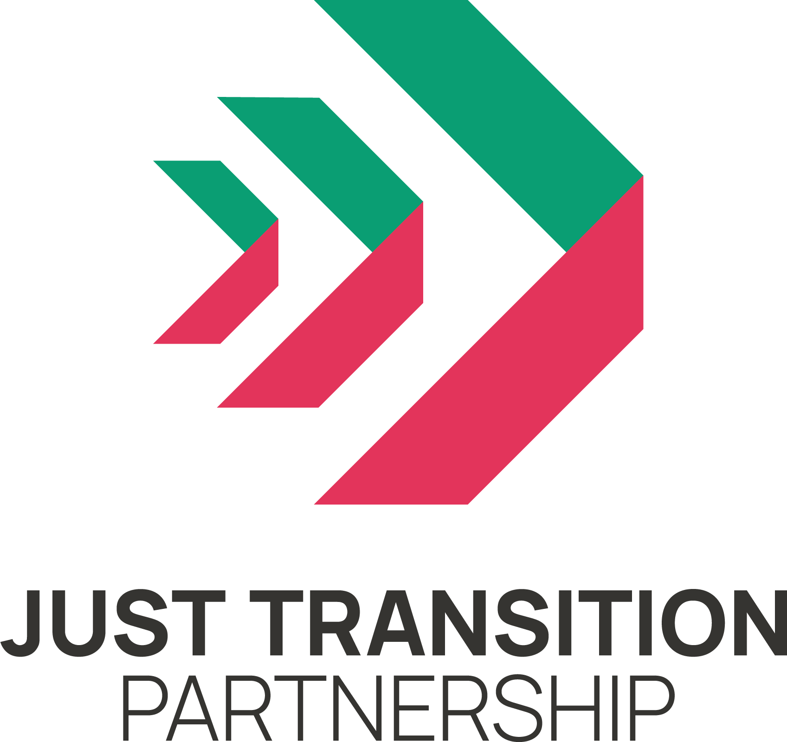
Roundtable on Just Transition Plan for
Transport
14 June 2023

Summary

On June 14th, 2023, the Just Transition Partnership held a roundtable discussion focused on the transport sector. This roundtable brought together representatives from trade unions, environmental and climate campaign groups, and disability rights groups.

Ahead of the Scottish Government’s Just Transition Plan for the transport sector, the Partnership invited these groups to share their immediate priorities for transforming the way we travel across Scotland in a way that delivers on our climate targets while improving the lives of workers and communities.

This summary has been drawn from contributions made by all participants. It does not necessarily represent the views of the Just Transition Partnership or its members.

CONTEXT

The discussion began by reflecting on the state of the sector today before moving into a identifying a shared vision for the future. The final section brought forward the immediate and long-term solutions to bring the vision into reality.

We identified these people as key for protecting and ensuring benefits: low-income working-class people who need access to public transport, disabled people, people with access needs, rural communities, less connected communities, and transport workers themselves.

At the structural level, several weaknesses were identified which act as barriers to the delivery of a coordinated, reliable, and integrated transport system across Scotland. These must be addressed to ensure granular and modal specific plans can have maximum impact:
- The relation between local authorities, the Scottish Government and Westminster is poor and contributes to disjointed and uncoordinated transport provision. A collective vision and approach are necessary.
- There is an extreme variation in the standard of transport within areas of Scotland. Infrastructure and level of services between the busiest routes such as buses and trains between Glasgow and Edinburgh are extraordinary compared to the reliability and quality of service in the Highlands and Islands.
- The fragmentation of transport due to franchising and the role of private companies is a stumbling block to meaningful progress in improving affordability and increasing services

Transport in Scotland: where are we now? Who benefits? Who faces challenges?

Across all discussions, there is a collective frustration that Scotland’s transport system is failing to serve the majority of people. The privatisation of public transport over several decades has created a fragmented, expensive, and unreliable service. Private car use is stubbornly high and accounts for the bulk of transport emissions despite car ownership being largely in the hands of those with higher incomes.

At the general level, delivering on climate targets for transport, as well as meeting the target to reduce car mileage by 20% by 2030 will require a significant move from cars to public and active travel. Yet public transport is often viewed negatively and not user friendly. Services run on a declining number of routes, fragmented ticketing causes confusion, and concerns about safety are exacerbated by poor late night or early hour services and ongoing threats to key transport workers at stations.

For particular groups, the shift to public transport will be less viable, in these cases more bespoke support and policy intervention will be necessary to avoid transport isolation. For large rural areas, electric vehicles will be crucial but charging provisions remain limited. For low-income households and people with disabilities in rural and urban areas, transport can be prohibitively expensive and inaccessible.

Key outcomes for the Just Transition Plan for Transport ‘State of the Sector’:
- Private car use has been prioritised for too long despite being largely in the hands of those with highest incomes.
- Privatisation of public transport has led to fragmented, expensive, and unreliable services across the country.
- The failure to meet climate targets is in part due to the continued prevalence of private car use coupled with unattractiveness of alternatives such as public transport.
- Within the general trends, the transport sector is particularly failing to meet the needs of low-income households, people with disabilities, and rural communities.

OUR VISION FOR TRANSPORT

In identifying a collective vision for transport, discussion began at a broad and general level before diving deeper into specific visions for different transport modes.

There is a shared consensus that public ownership is essential for ensuring accountable, participative, and sustainable transport networks. Delivering on a vision for transport that serves the majority relies upon ending profit motives that currently obstruct decent services.

Core to this is the importance of reducing costs and improving accessibility of public transport, ensuring good industrial relations and proper collective bargaining for workers, and integrating services to make public transport options far easier and coordinated with active travel networks.

For specific groups, our future transport system must be reliable and accessible with embedded prioritisation of services for disabled people. Stations and services are well staffed at all times to make people, particularly women and girls, feel safe. Alongside staffing levels, practical interventions enhance safety and end the burden of responsibility for ‘feeling’ and ‘being’ safe falling to women and girls. These changes make public transport safer and easier to use to support vulnerable groups and those less familiar with public transport to enjoy the opportunities it brings.

Rural communities are served by public transport options which are adapted for their unique circumstances, and sufficient infrastructure is provided to ensure electric vehicles are viable for those particularly hard to reach areas.

Workers across the transport sector, from drivers and maintenance staff to the manufacturing and supply chain, are involved in planning the future of their sector and empowered to lead the transition through their skills and experience.

Car use will be reduced; a positive vision for traffic reduction focused on clean air, safer roads, and more space for people to end the dominant car culture. Support for people immediately affected in their trades such as taxi drivers or council workers within LEZs must be more comprehensive as conflict on these issues is a barrier to further change. Road and car pricing must be reviewed to ensure those on highest incomes pay the most for transition while a proper review of the impact on revenue from the shift to EVs must be considered. Air pollution and car accidents which disproportionately affect low-income communities are significantly reduced to improve the lives of those living in these areas.

Air travel will be reduced; reducing emissions from air travel can be targeted at frequent flyers and those using private or charter flights as those with the highest incomes. Airport expansion is halted.

Our bus networks will be transformed; Far greater municipalisation of buses can address declining services, working conditions and passenger numbers. The end of profit motives means services are guided by greatest need, avoiding duplication of cash cow routes. Domestic manufacturing is supported to deliver new fleets while creating quality work.

Rail travel is electrified and well-staffed; The recent nationalisation of Scotrail and the Caledonian Sleeper is a turning point for providing the investment to electrify the network, reduce costs to make rail more affordable and maintaining accessibility and safety through the retention of staffing levels and station staff.

Lifeline ferries and maritime travel chaos is fixed; The ownership of CalMac means services can serve local needs while being aligned to wider public transport integration. Seafarers and port workers are protected and empowered through collective bargaining and their work is expanded into coastal shipping to reduce vehicle numbers further where possible.

Cycling, walking and other active travel is safe and common sense; Success of early active travel infrastructure is massively expanded to make this option a safer and easier choice. These routes are integrated with other public transport options to facilitate further connected journeys.

Key outcomes for the Just Transition Plan for Transport ‘Vision’:
- The future of public transport must be in municipalisation and greater public ownership to end the systemic failures of a ‘for profit’ transport system.
- Improving accessibility and reducing costs, rebuilding industrial relations and maintaining staff, and integrating public transport modes are essential.
- The general transformation for the sector sees a shift in priorities from private cars and towards high-quality, reliable, and affordable public transport alongside safer and coordinated active travel routes.
- The outcomes for different transport modes necessary to deliver a just transition are varied but each requires its own bespoke focus and delivery plan alongside strategic coordination to build an easy to use and reliable network within and between all areas of Scotland.

IDENTIFYING SOLUTIONS TO DELIVER OUR VISION

Our collective vision for transport in Scotland would bring significant benefits to a majority of people across the country. It would open up public space for people, reduce air pollution, create jobs, and improve the accessibility and reliability of transport options to those on the lowest incomes, people with disabilities and those in rural areas.

Delivering a just transition to reach this vision cannot be provided through a single approach. It is necessary to rectify structural issues to provide solid foundations and while there are several immediate steps which the Scottish Government should take, there are also longer-term policies that will be necessary to shift how people travel in Scotland and ensure the full range of benefits can be captured for all.

The steps identified in the following sections are highlighted based on their relevance to the upcoming Just Transition Plan. They are actionable immediately within the Scottish Government’s powers and core to the delivery of a just transition that can meet climate targets, protect, and improve jobs and industrial relations, and create a transport network that serves all of Scotland’s communities.

Immediate interventions and policies to outline in the Just Transition Plan

- Infrastructure
  - Use the nationalisation of Scotrail and the Caledonian Sleeper to begin creating an integrated model of public transport that ends fragmentation.
  - Create a way to plan and build Scotland’s public transport network alongside and between local authorities.
  - Assess the investment needed to electrify trains further, including the potential job creation and a timeline for delivery.
  - Begin planning for an integrated and publicly owned transport network to set out milestones and target dates on the way to providing coherence and coordination across all public and active travel options.

- Funding
  - Increase funding to local authorities to ensure new powers and any coordination efforts can be delivered by local government through municipal ownership.
  - Integrating access and disability, as well as income assessments, into all transport decisions to ensure transport funding is better balanced between cars, public transport, and active travel.
- Access
  - Support trials of free public transport as recommended by the Just Transition Commission urgently and in the meantime extend free public transport to those on low incomes, including asylum seekers and people receiving benefits.
  - Support the unique challenges facing people in the Highlands and Islands with a bespoke section of the plan that considers the necessary investment and transport system necessary to support these communities.
  - Implement plans for 20-minute neighbourhoods and share details within communities about changes to come and multiple co-benefits while ensuring local communities are about to shape the design and vision for their surroundings.
- Workers and jobs
  - End the threats to Scotrail services and staffing levels to rebuild industrial relations post-Abellio ownership and to improve perceptions of safety and ensure accessibility.
  - Commit to ending subsidies to private operators who are driving services and working conditions and begin to redirect those funds to local authorities to enable municipalisation.
  - Bring workers across the transport sector into transition planning to ensure their skills and experience guide the delivery of plans while building the capacity of workers to advocate and demonstrate the positives of a transformation in how we travel.

